**INFORMATION MANAGEMENT**

**Exercise 13**

1. Which command displays the MySQL version?

SELECT VERSION();

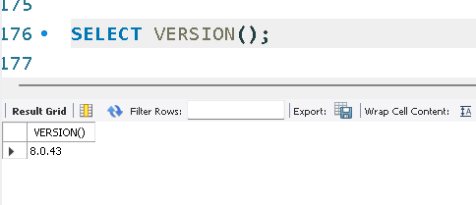

2. Use the SELECT command to evaluate 4 X 4 X 4 and name the column Cube of 4.

SELECT (4*4*4) AS `Cube of 4`;

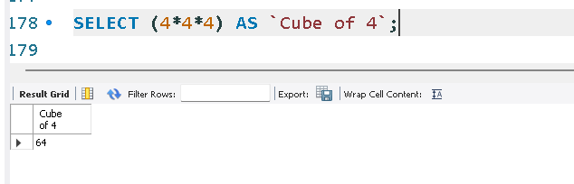

3. Display your name with SELECT.

SELECT 'Kenji Yonaha';

